|  |  |  |  |
| --- | --- | --- | --- |
| Name:  Teacher: | ____________________________________  ________________ | | Date:_________ |
|  | **Year 11 Mathematics Essentials**  SCORE: / 57    **Topic – Percentages, Ratios and Rates**  ***Full working out MUST be shown to get full marks for each question.*** | | |
| **Total Time:** | 50 minutes |  | |
| **Weighting:** | 10 % |
| **Equipment:** | To be provided by the student: Pens and Pencils, scientific calculator, A4 page of notes. | | |

**Question 1:**  [5 marks]

City Beach Surf Shop is having a Winter Sale to clear out their Summer gear.

1. If a T-shirt that normally costs $90 is on sale for 15% off what is the new price?
2. When paying for the t-shirt, City Beach offers an extra 5% discount at the till if paid with cash. How much is the T-shirt worth if a customer pays with cash?
3. A Scuba set (goggles and fins) originally cost $120 but is discounted by 20%. At the till the customer pays with their credit card, which has an additional fee of 2%. What is the overall percentage discount for the scuba set?

**Question 2:**  [7 marks]

1. Calculate the simple interest earned on an investment of $2540 at 9% p.a. for 2 years.
2. Calculate the simple interest earned on an investment of $5320 at 6% p.a. for 14 months.
3. Sally made loan repayments totalling $4320 on an initial loan of $4000 over 4 years. Calculate the rate of interest charged on the loan.
4. Tara takes out a car loan of $6000 at a simple interest rate of 8% p.a. She plans to repay the loan over 2 years. What will her monthly repayments be?

**Question 3:**  [2 marks]

* 1. In a class of 40 students there are 15 girls; Write the ratio of boys to girls as a simplified ratio.
  2. What percentage of the class are boys?

**Question 4:**  [4 marks]

Three friends bought a lottery ticket for $20; Sophie put in $10, Karen paid $6 and Tony paid $4. They agreed that if they won any money, they would split it in the ratio of the money they each put in. [4 marks]

* 1. What is the simplified ratio of the amount each person paid?
  2. If they won $1000 how much would each person get?

**Question 5:** [6 marks]

1. Circle two rates that are equivalent:
2. Writing 34 words per second
3. Writing 68 words in 30 seconds
4. Writing 714 words in 21 minutes
5. Writing 816 words per hour
6. Writing 34 words per minute
7. A cyclist travels 70 metres per 10 seconds. What is the speed of the cyclist in metres per minute?
8. A local cyclist thinks that she can ride her bike as faster than Usain Bolt can run; if the cyclist timed herself over 1km and it took 2 minutes, and Usain Bolt’s 200m record is 20 seconds which one is going the fastest?

**Question 6:** [3 marks]

Use the diagram below to answer the following questions

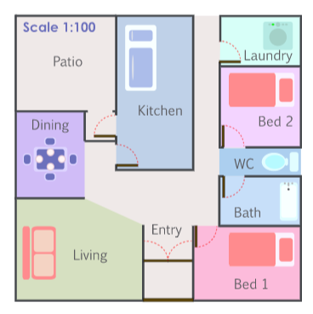

1. According to the scale on the diagram. 1 cm represents how many metres in the house?
2. Using a ruler Jill measured the length of Bedroom 1 on the plan and finds it to be 4 cm. How many metres is this?
3. Jill measured the width of Bedroom 1 and finds it to be 8.5 cm. How many metres is this?

**Question 7:** [3 marks]

A piece of rope is cut into three lengths in the ratio of 2:3:5. If the smallest length is 6m, find the length of the original rope.

**Question 8:** [4 marks]

At Mad Mike’s Petrol Station there is a special promotion happening that lets customers fill up their tank for a flat price of $80 regardless of how much fuel they buy.

Next door is Baldy’s Boring Petrol Station which has no specials, just the standard price of 147.9 cents/Litre.

1. If your tank is nearly empty and it normally takes 55 Litres to fill up, which petrol station is going to give you the best value for money?
2. How much would you save with this option?
3. In Mad Mike’s they sell six-packs of Coke for $15. How much does each can cost?

**Question 9:**  [5 marks]

Spud Shed normally sells a large (10 kg) bag of Potatoes for $12, or a medium (4 kg) bag costs $5. Loose potatoes (pick as many as you want) cost $1.80 / kg.

1. Put the three options in order from best value for money to worst value (show your working)
2. If you are cooking a meal that requires 3 kg of potatoes which option would cost the least?

**Question 10:**  [10 marks]

The following box and whisker graphs show the number of stocks (shares in the company) sold per day over a year. Answer the questions below that relate to these 3 graphs.

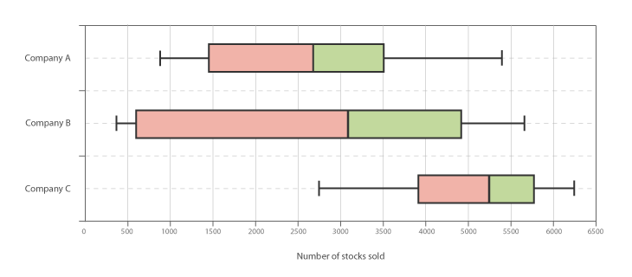

1. Write out the 5-number summary of Company A:
2. Company ________ has the highest median.
3. Company ________ has the smallest interquartile range.
4. Company _______ has the largest range.
5. You are told that one of the companies had over 4000 stocks sold yesterday. Which company is this most likely to be and why?

**Question 11:**  [2 marks]

Two classes sat a test and their results are shown below. Use the mean and standard deviation to compare the test results of the two classes.

|  |  |  |
| --- | --- | --- |
|  | mean | Standard deviation |
| Class A | 55% | 6.3 |
| Class B | 57% | 8.1 |

**Question 12:**  [6 marks]

The shapes of the graphs below can be described using the words “positive Skew”, Negative Skew”, “symmetrical” and “Bimodal”. Underneath each graph, write the most appropriate term.

1. 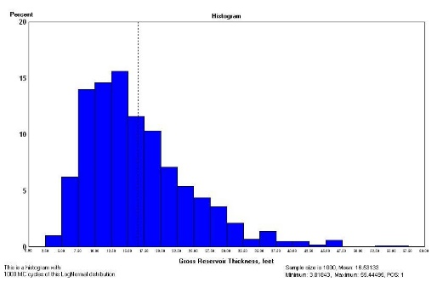 B)

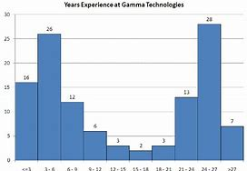

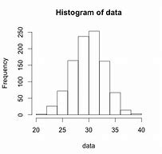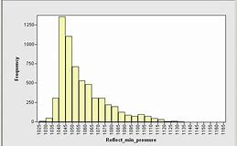

C) D)

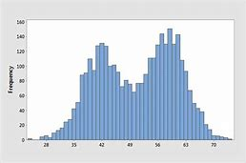 E) F)

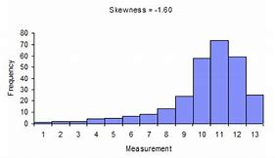

END OF TEST 😊